一、技术方案
子任务

功能划分 | 子模块 | 示例 | 备注
功能入口显示 | ☐ 根据当前选中账号判断切换为‘跨境店铺’tab  ☐ 我的页面，根据是否存在跨境版。显示‘AI助理 ’入口  ☐ webview容器，增加显示来源能力 | 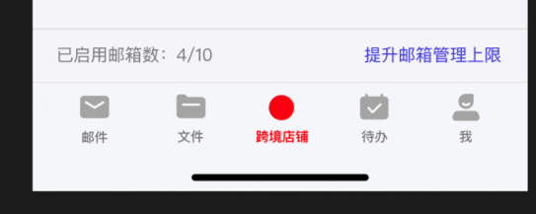  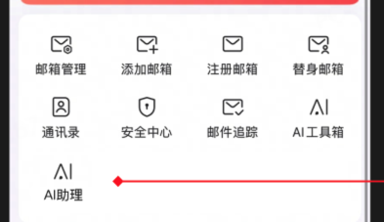
跨境店铺页面区块展示 | ☐ 跨境店铺邮箱- 开启跨进版邮箱  ☐ 非跨境版邮箱- 未开启跨境版邮箱  ☐ 待启用店铺邮箱- 大师号下绑定未启用邮箱  ☐ 邮箱登录个数提示 | 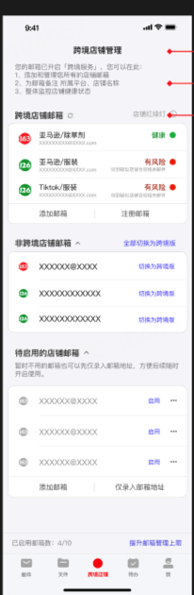
跨境店铺区块 | ☐ 店铺健康度tips- 点击显示弹窗  ☐ item展示（备注名/邮箱地址）  ☐ 健康度展示- 内域服务端下发 、外域移动端根据本地邮件结合规则判断  ☐ 添加邮箱- 打开添加邮箱页面  ☐ 注册邮箱- 打开注册邮箱页面 (是否需要先展示注册类型选择弹窗？ ) | 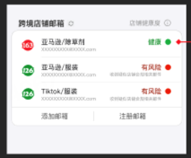
非跨境店铺区块 | ☐ 支持折叠  ☐ 一键全部切换为跨境版 - 端侧提供Hybrid  ☐ item展示（备注名/邮箱地址）  ☐ 单个切换为跨境版- 端侧提供Hybrid  ☐ 弹窗- 查看邮件- 切换到对应tab收件箱  ☐ 弹窗- 修改备注- 打开全屏备注页（需要开发支持）  ☐ 弹窗-邮箱设置- 跳转邮箱设置页面 | 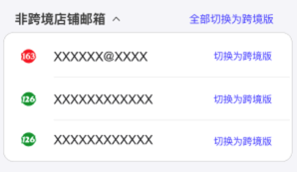
待启用邮箱区块 | ☐ 支持折叠  ☐ 根据是否登录大师号展示不同状态  ☐ 启用- 同现有启用流程 (需要全屏展示)  ☐ 添加邮箱- 同现有添加流程  ☐ 仅录入邮箱地址- 需要服务端提供特定能力（涉及到流程修改、本期可不做） | 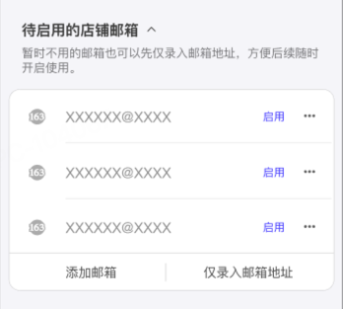
已启用邮箱模块 | ☐ 显示已登录邮箱  ☐ 当前账号体系在登录邮箱上限 | 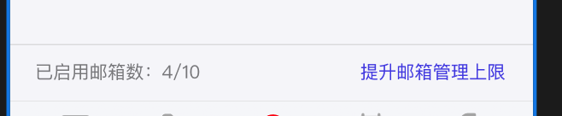
通知 | ☐ tab区域根据红绿灯状态，展示角标提示  ☐ push通知 | 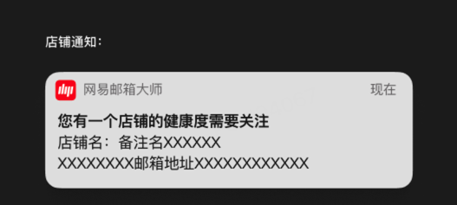  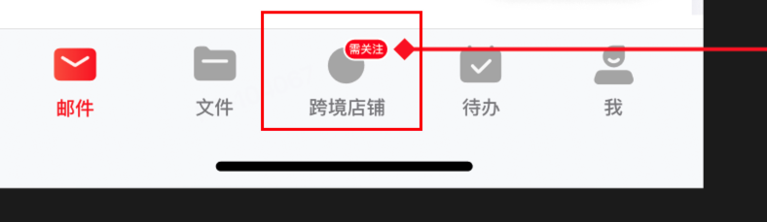
流程图
@startuml
actor user
participant app as app
participant TabManager as tab
participant 店铺管理页rn as rn
participant 服务端 as server
user -> app : 用户进入app
app -> tab : 显示底部tab
tab -> app : 设置账号变更&行业变更监听\n(用于账号状态变更刷新tab显示内容)
note top #red : 如果AI助理在使用中或店铺管理页使用中切换也直接切换
alt 选中账号非跨境or所有xxx中不存在跨境版
tab -> app: 展示原有tab模式
else 当前账号为跨境版or 所有xxx下存在跨境账号
tab->app: 需要展示跨境店铺管理页
app -> app: 初始化RN引擎，
app -> tab: 提供rn容器进行展示
end
group 店铺管理页展示逻辑
rn-> app: 通过hybrid获取账号信息&大师登录信息\n 设置新邮件接收通知(用于触发刷新获取健康度)
note right : 账号添加、删除等通知依赖tab切换刷新
app -> rn:返回账号信息
rn -> app: 根据账号获取健康度状态(批量获取)
group 红绿灯判断逻辑
note right :考虑到端侧需要复用健康度状态进行角标提示。\n 直接返回RN已经处理好的健康度状态
app -> app : 从阿波罗中读取配置(暂定方案)
app -> app: 外域根据获取到配置进行端侧逻辑处理\n内域根据服务端打标判断(内域方案待讨论)
app -> app : 根据获取到的规则进行判断，同时缓存处理结果，用于后续性能优化。
app -> rn: 回调健康度状态
end
end
group 触发RN刷新时机
app -> rn: 账号列表发生变更
app -> rn: 账号行业状态发生变更
app -> rn : 收到新信
app -> rn : 前后台切换/页面显隐
end
group 红灯消失规则
user -> app: 用户已读
end
@enduml
Hybrid
已有Hybrid桥接
Hybrid | 说明 | 是否已有H5接口 | 修改类型
GET_ACCOUNT_LIST | 获取已登录账号列表 | 是 | 桥接 & 新增备注remark
VALIDATE_MASTER_SESSION | 获取大师号是否登录 | 是 | 桥接
GET_MASTER_USER_INFO | 获取大师号信息 | 是 | 桥接
LOGIN_MASTER | 获取大师session | 是 | 桥接
GET_IDENTITY_INFO | 获取行业信息 | 是 | 桥接
NAVIGATE_FROM_NOTIFICATION | 定位某个账号下的收件箱文件夹 | 是 | 桥接（可用性TODO）
NAVIGATE_TO | 路由到原生界面 | 是 | 桥接
新增
- SET_IDENTITY_INFO @吴东
设置行业信息
MasterBridge: https://union.127.net/master-bridge/pages/mobile:master-bridge.main.clientmodule.dispatchmap.set_identity_info/

{
"accountId":"1",
"accountIndustry"： IdentityAccountIndustry //定义见https://union.127.net/master-bridge/pages/master-bridge.main.identityaccountindustry/
}
- 通知账号状态变更 @吴东账号变更通知 bridge
复用 NOTIFICATION_RECEIVED 定义
account:listChange
account:authUpdate
//本次可不支持大师号相关变更
account:plusPaytypeChange
account:masterPaytypeChange
account:masterValidChange
- 通知新增邮件
RN消息通道 ON_NEW_MAIL
通知页面刷新
MasterBridge: https://union.127.net/master-bridge/pages/mobile:master-bridge.main.mailmodule.subscribemap.on_new_mail/

{
"accountId":"1",
"list":[mailInfo] https://union.127.net/master-bridge/pages/master-bridge.main.mailinfo/
}
- 通知行业变更
NOTIFICATION_RECEIVED 通道
邮箱行业发生变更
account:industryChange
{
"accountId": 1,
"oldIndustry":"CAMPUS",
"newIndustry":"CROSS_BORDER"
}
- 健康度获取
GET_ACCOUNT_HEALTH_STATUS
获取跨境账号的健康度状态，非跨境或者未命中风险均返回normal ，支持批量查询
MasterBridge : https://union.127.net/master-bridge/pages/mobile:master-bridge.main.accountmodule.dispatchmap.get_account_health_status/
{"list":[{
accountId:"1"
} ,{
accountId:"2"
} ]，
"forceRefresh"：true/false //默认false
}
{"list":[
{
"accountId":"1",
status: "normal" //"normal"|"risk"
},
{
"accountId":"2",
status: "normal" //"normal"|"risk"
}
]}
- 注册邮箱
REGISTER_NEW_ACCOUNT
复用NAVIGATE_TO ，增加path
path register
显示注册类型弹窗，无回调，仅调用注册流程
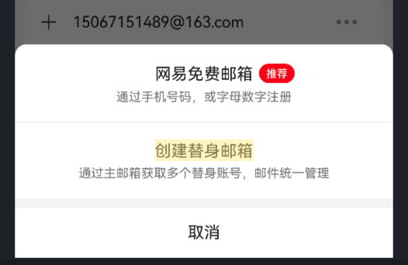
- 启用邮箱
ENABLE_ONLINE_EMAIL_IN_MASTER
复用 webui login_account 方法
https://union.127.net/master-bridge/pages/mobile:master-bridge.main.accountmodule.dispatchwithcompletionmap.login_account/#login_account
{
"uid":"wsss@163.com"
}
- 删除未启用邮箱 二次删除确认弹窗需要前端实现@吴东
DELETE_ONLINE_EMAIL_IN_MASTER
删除大师号中的邮箱 ，触发原有删除确认弹窗展示
MasterBridge: https://union.127.net/master-bridge/pages/mobile:master-bridge.main.mastermodule.dispatchmap.delete_online_email_in_master/
{
"email":"wsss@163.com"
}

- 健康度通知开关 本期不做
GET_ACCOUNT_HEALTH_PUSH_SWITCH
仅针对内域做push
{
"enable":true/false
}
- 健康度通知状态设置本期不做
SET_ACCOUNT_HEALTH_PUSH_SWITCH
{
"enable":true/false
}
- 获取邮箱列表
GET_MASTER_EMAILS
复用邮箱管理中返回给flutter定义 ，
MasterBridge: https://union.127.net/master-bridge/pages/mobile:master-bridge.main.mastermodule.dispatchmap.get_master_emails/
{
"masterAccountLogined" : 1, //大师号是否登录
"masterQuickLoginEnabled" : 1,// 是否支持快速登录
"isDaShiVip" : true,// 是否大师vip
"emailsAmount" : 10, // 最大登录邮箱数量
"emailsAccountNumber" : 4, //已登录邮箱数量
"localAccounts" : [ { // 已登录邮箱信息
"id" : 4,
"type" : 1,
"email" : "wswtest01@163.com",
"name" : "测试备注图太可怜了考虑考虑咯啦啦啦蓝蓝蓝蓝蓝聚聚会蓝蓝蓝聚聚", //备注
"oauth" : false,
"enterprise" : false,
"invalidAuth" : false,
"isPlus" : false,
"isSuperVip" : false
}, {
"id" : 4,
"email" : "wswtest01@163.com",
"isSubstitute" : true,
"boxId" : "1020",
"boxName" : "订阅新闻资讯"
}, {
"id" : 3,
"type" : 1,
"email" : "zhucheng@163.lunkr.cn",
"name" : "zhucheng@163.lunkr.cn",
"oauth" : false,
"enterprise" : false,
"invalidAuth" : false,
"isPlus" : false
}, {
"id" : 5,
"type" : 1,
"email" : "xwstest240526@163.com",
"name" : "xwstest240526@163.com",
"oauth" : false,
"enterprise" : false,
"invalidAuth" : false,
"isPlus" : false,
"isSuperVip" : false
}, {
"id" : 6,
"type" : 1,
"email" : "xwstest240529@163.com",
"name" : "xwstest240529@163.com",
"oauth" : false,
"enterprise" : false,
"invalidAuth" : false,
"isPlus" : false,
"isSuperVip" : false
} ],
// 大师号中绑定未启用邮箱列表
"onlineEmails" : [ "xwstest240524@yeah.net", "qtest_m9tt9bry_s75@163.com", "mailtestqa@163.com", "15067151489@163.com", "xwstest240530@126.com", "zhucheng1215@elysys.net", "xwstest240524@126.com", "xwstest240531@163.com", "zhucheng1218@devtest.com", "alsowellchen@gmail.com", "mailtestqa35@yeah.net", "wangxiaoer2017@gmail.com", "xwstest240526@yeah.net", "xwstest240620@163.com", "mailtestqa17@126.com", "xwstest240524@163.com", "xwstest240528@yeah.net", "mailtest210312@yeah.net", "mmtest001@vip.163.com", "xwstest240526@126.com", "chenan02@corp.netease.com" ],
"accountSortType" : 0
}

{
"id": 1, // int - 账号ID
"email": "user@163.com", // string - 邮箱地址

"type": 1, // int - 协议类型: 0=Unknown, 1=WZP(网易), 2=IMAP, 3=POP3, 4=Exchange
"name": "用户昵称", // string - 显示名称（displayName为空时回退为email）
"oauth": false, // boolean - 是否使用OAuth认证（true仅在非WZP协议且启用OAuth时）
"enterprise": false, // boolean - 是否为网易企业邮箱
"invalidAuth": false, // boolean - 认证是否失效（true=未通过认证/凭证过期）
"isPlus": false, // boolean - 是否为Plus会员
"isDuplicateAccount": true, // boolean - [条件字段] 是否为重复账号，仅当 type=WZP 且非企业邮箱 且账号标记为重复时才出现
"isSuperVip": true, // boolean - [条件字段] 是否为超级会员，仅当存在AccountSpaceInfo且isAccountSpaceType时才出现

"isSubstitute": true, // boolean - 固定为true，标识此条目为替身邮箱
"boxId": "substitute_key_001", // string - 替身邮箱的Mailbox Key（替身邮箱按key倒序排列）
"boxName": "我的替身邮箱" // string - 替身邮箱的显示名称
}

字段 | 类型 | 普通账号 | 替身邮箱 | 是否必有 | 条件说明
id | int | ✅ | ✅ | 必有 | 账号ID，替身邮箱与其所属主账号的id相同
email | string | ✅ | ✅ | 必有 | 普通账号为自身邮箱地址，替身邮箱为所属主账号邮箱地址
type | int | ✅ | ❌ | 普通必有 | 0=Unknown,1=WZP,2=IMAP,3=POP3,4=Exchange
name | string | ✅ | ❌ | 普通必有 | displayName非空时用displayName，否则回退为email
oauth | boolean | ✅ | ❌ | 普通必有 | account.useOAuth() && !account.isWZPProtocol()
enterprise | boolean | ✅ | ❌ | 普通必有 | account.isNeteaseEnterpriseAccount()
invalidAuth | boolean | ✅ | ❌ | 普通必有 | !account.isAuthentication()
isPlus | boolean | ✅ | ❌ | 普通必有 | 通过AdService判断是否Plus会员
isDuplicateAccount | boolean | ✅ | ❌ | 条件出现 | 仅WZP协议 + 非企业邮箱 +isAccountDuplicate()=true时才 put
isSuperVip | boolean | ✅ | ❌ | 条件出现 | 仅存在AccountSpaceInfo且isAccountSpaceType()=true时才 put
isSubstitute | boolean | ❌ | ✅ | 替身必有 | 固定值true
boxId | string | ❌ | ✅ | 替身必有 | mailbox.getKey()
boxName | string | ❌ | ✅ | 替身必有 | mailbox.getName()
- 唤起备注
复用NAVIGATE_TO
{
"path":"nicknameEditorPage",

"params":{
"accountId":"1"
"email":"xxx@163.com",
}
}
flutter页面
router : normal/nicknameEditorPage
params{
"accountId":"1",
"email":"xxx"，
"currentNickname":"哈哈哈"，
"isCrossBorder":true, //
}
- flutter hybrid增加通过 industryId 获取描述方法
//入参
method: getIndustryDesc
{"industryId":"CROSS_BORDER"},
//response
{
"industryId":"CROSS_BORDER",
"industryDesc":"跨境版"
}
- flutter 登录页增加行业变更监听
eventName: onIndustryChange
{"accountId":"xxx","newIndustry":"CROSS_BORDER","oldIndustry":"GENERAL"}
PC:
交互调整：
- 账号列表根据账号的行业信息区分为店铺与其他两组，
- 跨境的账号会展示红绿灯图标
- 两组之间不允许跨组拖动
红绿灯判断规则：
- 判断范围:收件箱前一百封邮件
- 命中规则：邮件中包含下面标签信息，且是未读
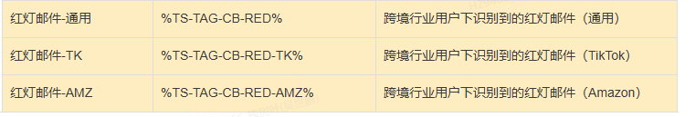
- 刷新时机: 冷启动，进信、未读状态变更、邮件移动、删除

相关规则配置
原有亚马逊相关
原有店铺通知 配置
{
"majorEnable": true,
"classifyRule": [
{
"sender": [
"mailtestqa",
"163"
],
"tagId": "C-T-BILL2",
"subject": [
"结算已完成",
"汇款明细",
"Payout Summary",
"Disbursement",
"入账",
"Payment is on the way",
"payment Credited",
"Funds credited",
"您的付款正在处理中",
"Votre paiement est en cours",
"Ihre Auszahlung wird ausgeführt"
]
},
{
"sender": [
"amazon",
"163"
],
"tagId": "CB-T-SETTLE",
"subject": [
"结算已完成",
"汇款明细",
"Payout Summary",
"Disbursement",
"入账",
"Payment is on the way",
"payment Credited",
"Funds credited",
"您的付款正在处理中",
"Votre paiement est en cours",
"Ihre Auszahlung wird ausgeführt"
]
},
{
"sender": [
"amazon"
],
"tagId": "CB-T-ORDER",
"subject": [
"新订单待处理",
"New Order #",
"立即发货提醒",
"已配送",
"Order Confirmed",
"Tracking Update",
"Shipment Confirmation",
"付款失败通知",
"Risk Hold Alert",
"地址无效需确认",
"Order Cancellation"
]
},
{
"sender": [
"amazon"
],
"tagId": "CB-T-LOGISTIC",
"subject": [
"逾期发货警告",
"Ship By",
"发货倒计时",
"配送延迟通知",
"清关问题提示",
"Delivery Failed",
"Customs Hold",
"已配送您售出的商品",
"物流赔偿通知"
]
},
{
"sender": [
"amazon"
],
"tagId": "CB-T-INV",
"subject": [
"低库存警告",
"FBA库存不足",
"Overstock Alert",
"Restock Recommendation",
"WFS"
]
},
{
"sender": [
"amazon"
],
"tagId": "CB-T-CMSG",
"subject": [
"亚马逊顾客",
"物流查询",
"订单咨询"
]
},
{
"sender": [
"amazon"
],
"tagId": "CB-T-EVT",
"subject": [
"黑五报名",
"限时促销邀请",
"Deal Registration",
"Prime Day 提报",
"网一报名",
"Promotion",
"Campaign",
"Sales Event",
"促销报名",
"活动报名",
"大促报名",
"Exclusive Sale Invitation"
]
}
],
"majorRule": [
{
"sender": [
"amazon",
"163"
],
"tagId": "CB-T-SNOTI",
"subject": [
"销售权限暂停",
"账户冻结通知",
"Account Restriction",
"Reinstatement Request Result",
"申诉结果通知",
"Appeal Approved",
"Appeal Rejected",
"复权申请回复",
"店铺审核",
"店铺冻结",
"account is under review",
"Information needed",
"Store Verification",
"Account Review",
"Document Submission",
"店铺验证",
"账户审核",
"提交信息",
"提交资料",
"Account Verification",
"Review Required",
"审核资料",
"验证资料",
"补充资料",
"产品下架警告",
"侵权投诉处理",
"Policy Violation",
"Intellectual Property",
"Complaint",
"Infringement",
"ASIN",
"侵权",
"Infringement Notice",
"Intellectual Property",
"Infringement",
"Copyright",
"Violation",
"知识产权",
"版权",
"违规",
"商品侵权",
"Product infringement",
"A-to-Z",
"纠纷待响应",
"INR Case Opened",
"Dispute Resolution Required ",
"A-to-Z Claim",
"赔偿通知",
"绩效报告",
"ODR状态更新",
"Account Health Report",
"Performance Notification",
"Account Health",
"At Risk",
"Performance",
"Metrics",
"Account Health",
"Order Defect Rate",
"绩效",
"指标",
"账户健康",
"订单缺陷率",
"绩效",
"Performance Alert"
]
}
],
"classifyEnable": true
}
整体沿用原有部分配置，新增字段标识多场景标签
{
...
"majorRule":[
{

"sender":["163.com"] ,// 匹配wa邮箱， 如果为空，则不校验发件人，
///**

"subject":["xxx","xx"],//主题匹配，单个匹配。兼容原有配置
"multiSubject":[["xxx","xx"],["xx","xxx"]],// 需要同时匹配才算命中
"tagId":"%TS-TAG-IMPORTANT%" ,//原有目标标签，
"targetTagIds":["%TS-TAG-IMPORTANT%",""] ，//执行层，merge tagId 和 targetTagIds 进行统一打标
"priority": 0,//优先级 通用的放在更后面一点 0 ,1,2
}
]
}
TIKTOK
{
"majorRule": [
{
"sender": ["shop.tiktok.com"],
"targetTagIds":["%TS-TAG-CB-RED-TK%"] ,
"subject": [
"新违规提醒",
"节点处罚",
"长期不活跃商家",
"violation alert",
"Node penalty",
"Inactive merchant",
"立刻行动",
"Action Required",
"闭店",
"账户余额",
"Customer Dispute"
],
"multiSubject": [
["收到", "违规"],
["申诉", "失败"],
["申诉", "等待处理"],
["保证金", "缴纳", "提醒"],
["保证金", "补缴", "提醒"],
["尽快缴纳", "保证金"],
["Security Deposit", "Payment"],
["入驻审核", "未通过"],
["入驻审核", "未完成"],
["onboarding application", "not", "approved"],
["onboarding application", "not", "completed"],
["资质认证", "未通过"],
["brand qualification certification", "failed"],
["授权", "取消"],
["shop", "closed"],
["authorization", "cancelled"],
["退货", "待处理"],
["退款", "待处理"],
["Return", "pend", "process"],
["Return", "Received"],
["Refund", "pend", "process"],
["Refund", "Received"],
["客诉", "待处理"],
["客诉", "通知"],
["appeal", "failed"],
["appeal", "pend", "process"],
["received", "violation"],
["Run Out", "Balance"]
]
}
]
}
通用
{
"majorRule": [
...
{
"sender": [],
"targetTagIds": ["%TS-TAG-CB-RED%"],
"subject": [
"违规",
"警告",
"预警",
"处罚",
"Violation",
"Warning",
"Early warning",
"Penalty",
"不通过",
"失败",
"未完成",
"Not passed",
"Failed",
"Not completed",
"被取消",
"闭店",
"注销",
"余额不足",
"耗尽",
"到期",
"Cancel",
"Closed",
"deregistered",
"due",
"客诉",
"纠纷",
"争议",
"Customer Dispute",
"Dispute"
],
"multiSubject": [
["Run Out", "Balance"]
]
}
]
}
整体配置 （正式环境上线前需确认！ 跟正式配置merge）
{
"configs": [
{
"clientVersion": "7.24.3-7.24.11",
"enable": true,
"grepStrategy": "ALL-OPEN",
"master": false,
"maxGrepUser": 0,
"onlineTime": "2026-01-09 10:00:00",
"result": {
"classifyEnable": true,
"classifyRule": [
{
"sender": [
"amazon"
],
"subject": [
"结算已完成",
"汇款明细",
"Payout Summary",
"Disbursement",
"入账",
"Payment is on the way",
"payment Credited",
"Funds credited",
"您的付款正在处理中",
"Votre paiement est en cours",
"Ihre Auszahlung wird ausgeführt"
],
"tagId": "CB-T-SETTLE"
},
{
"sender": [
"amazon"
],
"subject": [
"新订单待处理",
"New Order #",
"立即发货提醒",
"已配送",
"Order Confirmed",
"Tracking Update",
"Shipment Confirmation",
"付款失败通知",
"Risk Hold Alert",
"地址无效需确认",
"Order Cancellation"
],
"tagId": "CB-T-ORDER"
},
{
"sender": [
"amazon"
],
"subject": [
"逾期发货警告",
"Ship By",
"发货倒计时",
"配送延迟通知",
"清关问题提示",
"Delivery Failed",
"Customs Hold",
"已配送您售出的商品",
"物流赔偿通知"
],
"tagId": "CB-T-LOGISTIC"
},
{
"sender": [
"amazon"
],
"subject": [
"低库存警告",
"FBA库存不足",
"Overstock Alert",
"Restock Recommendation",
"WFS"
],
"tagId": "CB-T-INV"
},
{
"sender": [
"amazon"
],
"subject": [
"亚马逊顾客",
"物流查询",
"订单咨询"
],
"tagId": "CB-T-CMSG"
},
{
"sender": [
"amazon"
],
"subject": [
"黑五报名",
"限时促销邀请",
"Deal Registration",
"Prime Day 提报",
"网一报名",
"Promotion",
"Campaign",
"Sales Event",
"促销报名",
"活动报名",
"大促报名",
"Exclusive Sale Invitation"
],
"tagId": "CB-T-EVT"
}
],
"majorEnable": true,
"majorRule": [
{
"priority": 0,
"sender": [
"amazon"
],
"subject": [
"销售权限暂停",
"账户冻结通知",
"Account Restriction",
"Reinstatement Request Result",
"申诉结果通知",
"Appeal Approved",
"Appeal Rejected",
"复权申请回复",
"店铺审核",
"店铺冻结",
"account is under review",
"Information needed",
"Store Verification",
"Account Review",
"Document Submission",
"店铺验证",
"账户审核",
"提交信息",
"提交资料",
"Account Verification",
"Review Required",
"审核资料",
"验证资料",
"补充资料",
"产品下架警告",
"侵权投诉处理",
"Policy Violation",
"Intellectual Property",
"Complaint",
"Infringement",
"ASIN",
"侵权",
"Infringement Notice",
"Intellectual Property",
"Infringement",
"Copyright",
"Violation",
"知识产权",
"版权",
"违规",
"商品侵权",
"Product infringement",
"A-to-Z",
"纠纷待响应",
"INR Case Opened",
"Dispute Resolution Required",
"A-to-Z Claim",
"赔偿通知",
"绩效报告",
"ODR状态更新",
"Account Health Report",
"Performance Notification",
"Account Health",
"At Risk",
"Performance",
"Metrics",
"Account Health",
"Order Defect Rate",
"绩效",
"指标",
"账户健康",
"订单缺陷率",
"绩效",
"Performance Alert",
"中国税务报告",
"Tax"
],
"tagId": "CB-T-SNOTI",
"targetTagIds": [
"%TS-TAG-CB-RED-AMZ%"
]
},
{
"multiSubject": [
[
"收到",
"违规"
],
[
"申诉",
"失败"
],
[
"申诉",
"等待处理"
],
[
"保证金",
"缴纳",
"提醒"
],
[
"保证金",
"补缴",
"提醒"
],
[
"尽快缴纳",
"保证金"
],
[
"Security Deposit",
"Payment"
],
[
"入驻审核",
"未通过"
],
[
"入驻审核",
"未完成"
],
[
"onboarding application",
"not",
"approved"
],
[
"onboarding application",
"not",
"completed"
],
[
"资质认证",
"未通过"
],
[
"brand qualification certification",
"failed"
],
[
"授权",
"取消"
],
[
"shop",
"closed"
],
[
"authorization",
"cancelled"
],
[
"退货",
"待处理"
],
[
"退款",
"待处理"
],
[
"Return",
"pend",
"process"
],
[
"Return",
"Received"
],
[
"Refund",
"pend",
"process"
],
[
"Refund",
"Received"
],
[
"客诉",
"待处理"
],
[
"客诉",
"通知"
],
[
"appeal",
"failed"
],
[
"appeal",
"pend",
"process"
],
[
"received",
"violation"
],
[
"Run Out",
"Balance"
]
],
"priority": 0,
"sender": [
"shop.tiktok.com"
],
"subject": [
"新违规提醒",
"节点处罚",
"长期不活跃商家",
"violation alert",
"Node penalty",
"Inactive merchant",
"立刻行动",
"Action Required",
"闭店",
"账户余额",
"Customer Dispute"
],
"targetTagIds": [
"%TS-TAG-CB-RED-TK%"
]
},
{
"multiSubject": [
[
"Run Out",
"Balance"
]
],
"priority": 1,
"subject": [
"违规",
"警告",
"预警",
"处罚",
"Violation",
"Warning",
"Early warning",
"Penalty",
"不通过",
"失败",
"未完成",
"Not passed",
"Failed",
"Not completed",
"被取消",
"闭店",
"注销",
"余额不足",
"耗尽",
"到期",
"Cancel",
"Closed",
"deregistered",
"due",
"客诉",
"纠纷",
"争议",
"Customer Dispute",
"Dispute"
],
"targetTagIds": [
"%TS-TAG-CB-RED%"
]
}
]
},
"type": "GREP"
}
],
"functionId": 73,
"functionName": "Function-External-Auto-Classify"
}
附录2：技术方案变更记录
20240808: 因XX调整需求，导致XX功能的技术方案变更，增加/减少工期XX人天
基本要求：
- 描述简明扼要
- 涉及人员及原因描述清楚
- 需求/技术方案变更对工期的影响
- 及时同步项目组成员
附录3：文档使用办法&修订记录
模板链接：技术方案通用模板V1.0
创建副本（如下图所示5个步骤）：
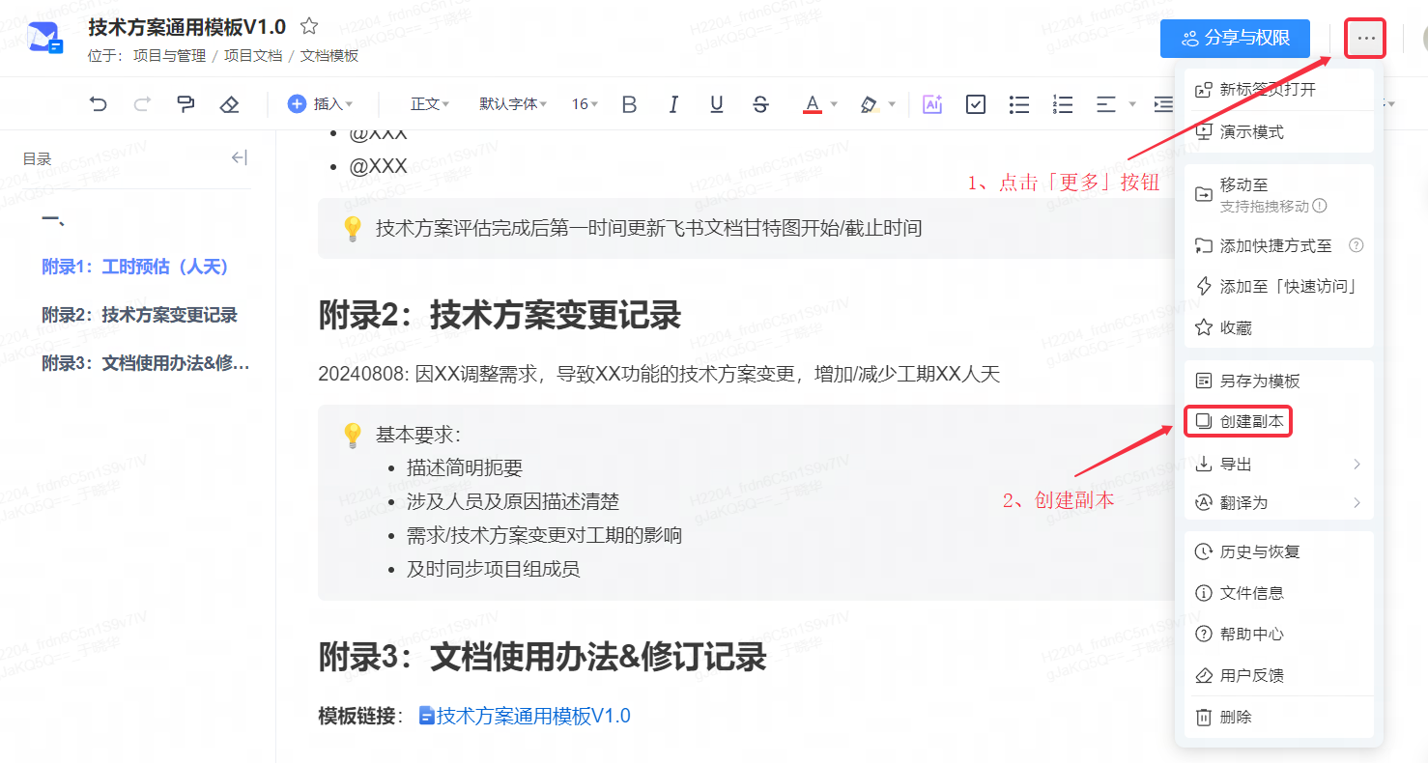

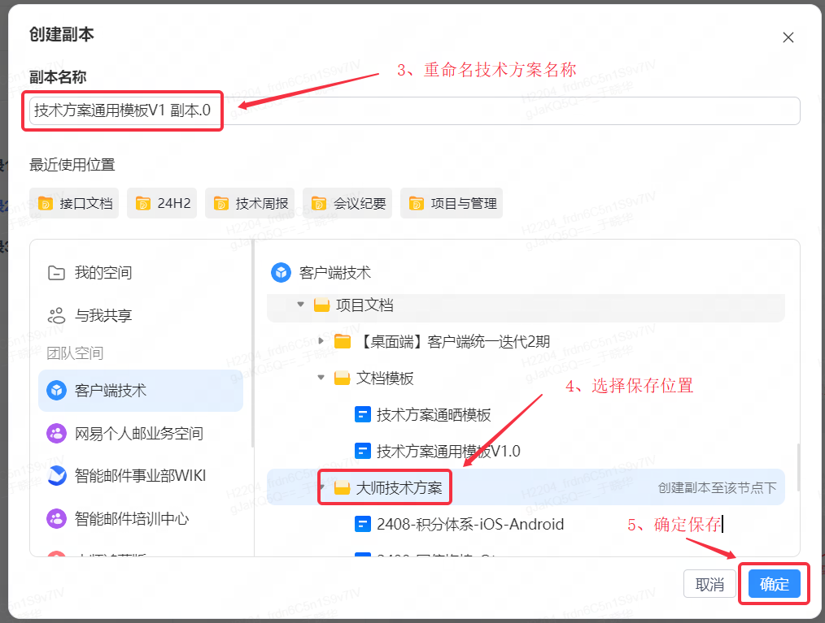
保存目录：/项目与管理/项目文档/大师技术方案
3.1 技术方案重点内容
1、数据库表新增与变更
重点描述DDL与DML；
2、新增在线配置及配置内容变更
重点描述Key及Value

3、核心业务逻辑（重点描述系统边界）
推荐配图描述，如：流程图，时序图，数据流图等
4、新增接口（Http和WZP接口，要求P3（含P3）以下必须提供）
描述接口功能，测试环境URL，生产环境URL

